Final Description

1. ER diagram

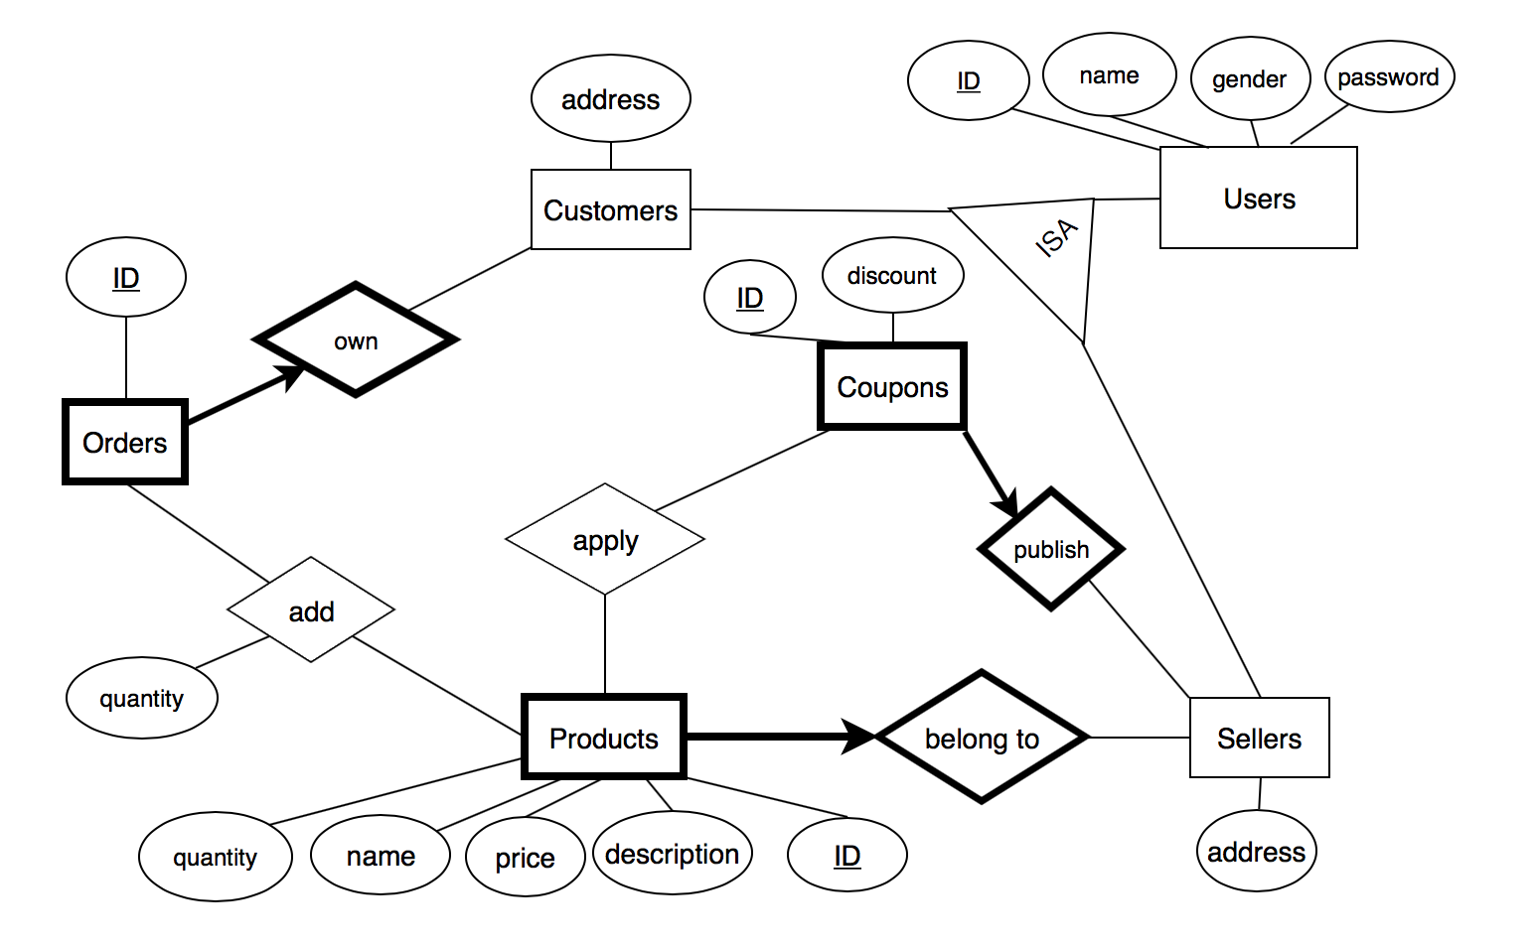

2. Database Table Design

comments:

Application: Realization in web server while not in database design

Underline: Primary Key

Tables:

users (user_id, name, gender, password) (application: name is unique)

customers (user_id, address)

sellers (user_id, address)

products (product_id, name, description, seller_id, price, quantity)

coupons (coupon_id, discount, seller_id)

orders (order_id, customer_id)

coupon_applied (coupon_id, product_id)

orders_products (order_id, product_id, quantity)

为什么选择单独列出table customesr和sellers:

方便代码拓展

为什么增加order_products:

重新定义需求后，一个订单可以有多类产品， 一类产品也可以在多个订单中

3. Details in Application

**Overview:**

如何生成并insert是primary key的id：

因为id应是server分配而不是用户输入，为方便起见，统一规定每次insert一条新的记录, 插入的primary key应为当前最大的id + 1.

例如数据库中已有id为1,2,3的user, 则插入的新user_id应为4. 其他也是如此。如果例如出现1,3的情况，因为数据库较小，不会影响数据库性能，此优化暂时不作考虑。

如何在设计页面逻辑时获取用户登录的个人信息（名字等）：

储存在全局变量session中。从一个人login成功到一个人logout这个时间段称为一个session. Flask提供了全局变量session（本质是一个dictionary）来储存用户的个人登录信息。

应充分考虑用户输入出错的情况，如注册的姓名已经存在等，需要在页面上显示出错误信息。以下业务流程均为常规正确流程，用户输入出错情况每个用例都需单独考虑。

应充分考虑页面之间的跳转，如卖家添加产品到一半突然不想添加了，需要一个按钮可以直接返回卖家主界面。

url和html文件命名规范: 使用_代替空格，空格容易出问题

**sign up：**

input on web: name, gender, password, select customer / seller, address

Insert: (user_id, name, gender, password) into users

if customer: insert (user_id, address) into customers

if seller insert (user_id, address) into sellers

success: to login page

failure: to sign up page

**login:**

input on web：name, password, select customer / seller

check name是否存在，password和选择是否正确

success: to customer / seller main page

failure: to login page

**Customer:**

customer main page:

directly list all the available products, price, coupon and let customer select and input quantity

a button: to my order

order main page:

should list all the orders belonging to the customer, let customer select one

a button: to customer main page

order xxx page:

should list all the products and corresponding coupons (don’t forget to provide a button for removing product and a blank to update the quantity of a particular product) and provide a button at bottom to calculate the total price of the order

a button: to return to my order main page

a button: pay the order (redirect to purchase success page)

purchase success page:

payment success!

a button: back to customer main page

**Seller:**

seller main page:

should contain the following buttons:

add product: to add product page

delete product: to delete product page

update product: to update product page

add coupon: to add coupon page

delete coupon: to delete coupon page

update coupon: to update coupon page

add product page:

input: name, description, price, quantity

insert (product_id, name, description, price, quantity, seller_id) into products

a button: back to seller main page

delete product page:

list all the products, quantity and price belonging to the seller first. A button ‘delete’ for each product.

After click the button, the product should be removed from the displayed list.

a button: back to seller main page

update product page:

list all the the products, quantity and price belonging to the seller first.

Let seller input the name, new price and new quantity.

update table products

a button: back to seller main page

add coupon page:

Similar to update product page.

delete coupon page:

Similar to delete product page.

update coupon page:

Similar to add coupon page.